# SANJALIKA WATERPARK SLIDE’S DESCRIPTION WITH MORE FEATURES

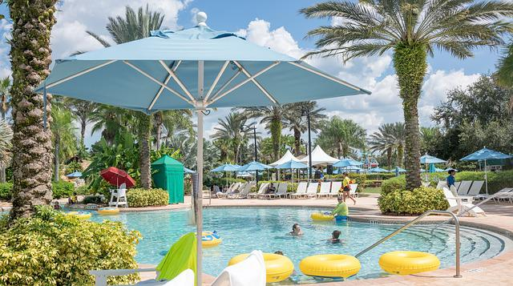

Figure sanjalika waterpark

Sanjalika Water Park is definitely an ultimate and out of the world source of entertainment. Decorated by mermaids, other statues, the Sanjalika Water park has largest cave and swimming pool area of modern technology a kind of place for thrills and fun. At Sanjalika Water park there is lot of water rides which are very exciting and thrilling.

In this document, you are gonna learn about more features of the slides with their information.

SURGE HURRICANE SLIDE

Water parks are amusement parks that consist of lots of slides, playgrounds, swimming pools and lots of other areas which are full of water but are covered with various roundabouts. Water parks are mostly the favorite place to visit for every child and a lot of families during the summer visit various water parks as well. There are a lot of famous water parks around the world, and here a few of those water parks would be discussed where one can enjoy a **water park picnic** with his family.

FEATURES OF THE SURGE HURRICANE SLIDE

The surge hurricane slide is the latest combination water slide in China which is combined by a super bowl and a hurriane wall.Riders first enter the super bowl from the spiral entrance and ripple along the spiral part for a fewmoments and then riders will be sucked into a black hole and fall into a hurricane wall slide,and eventually into the splash pool.

SURGE HURRICANE SLIDE IMAGES

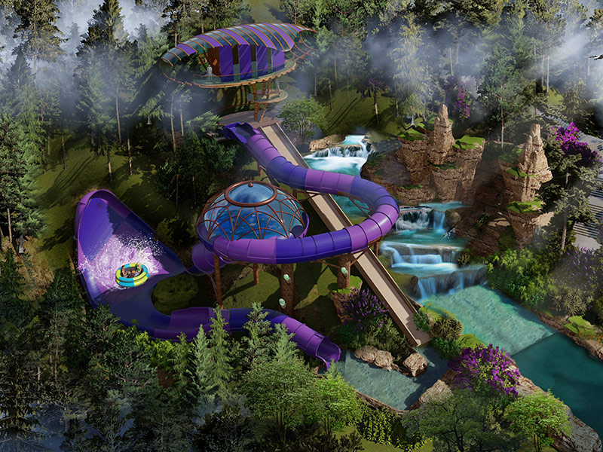

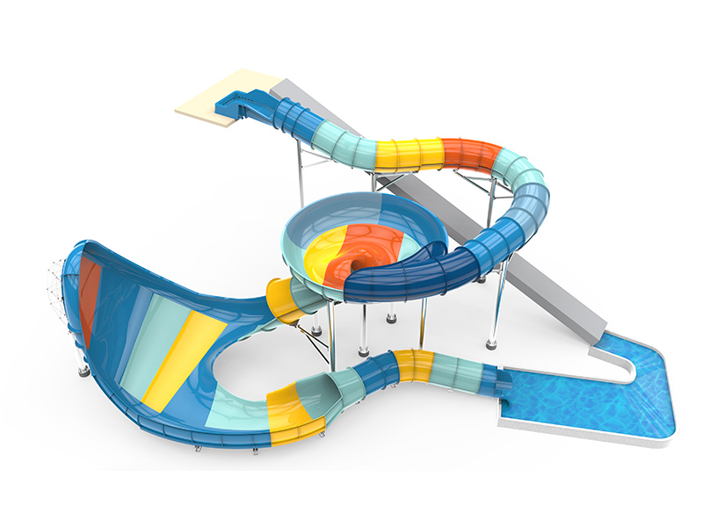

And many more images, customer feedback on such slides have alwaysbeen good and keeps getting better.

Thank you!